CHAPTER 1
COMPANY PROFILE

  - INTRODUCTION

Mind Matrix is an industry-oriented learning and competency development platform dedicated to bridging the gap between academic education and real-world industrial requirements for engineering students and young professionals. The organization focuses on providing practical, skill-based learning experiences that help students gain exposure to current technologies, industry workflows, and real-time project development environments. Through structured internship programs, industry-aligned courses, hands-on projects, cloud-based learning platforms, AI-driven applications, and mentorship sessions, Mind Matrix enables students to strengthen both their technical and professional competencies.

The platform emphasizes innovation, experiential learning, and continuous skill enhancement by introducing learners to modern technologies such as Android Application Development, Artificial Intelligence, Cloud Computing, UI/UX Design, Database Management, and Software Development methodologies. During the internship program, students were trained through a combination of theoretical learning and practical implementation activities that included Android Studio setup, mobile application development, AI integration using Generative AI tools, cloud platform exploration, database handling, debugging, and project deployment concepts. The internship also encouraged collaborative learning, problem-solving, analytical thinking, and real-world application development practices, thereby helping students improve their confidence, technical knowledge, and industry readiness while preparing them for future career opportunities in the technology domain.

  - MISSION

The mission of Mind Matrix is to empower students and aspiring professionals with industry-relevant technical skills, practical knowledge, and innovation-driven learning experiences. The organization focuses on reducing the gap between academic curriculum and industrial expectations by providing hands-on training, project-oriented learning, mentorship, and exposure to emerging technologies such as Artificial Intelligence, Cloud Computing, Android Development, and Software Engineering.

MindMatrix aims to create a strong technical foundation among students while encouraging creativity, analytical thinking, teamwork, and continuous learning. The company is committed to preparing students for real-world challenges by helping them gain practical exposure and confidence in modern software development environments.

  - VISION
The vision of Mind Matrix is to create a future-ready learning ecosystem that transforms students into skilled and industry-ready technology professionals. The organization envisions becoming a leading platform for technical education, innovation, and professional development by integrating modern technologies, practical learning methodologies, and real-world industry practices.

Mind Matrix strives to nurture innovation, creativity, and technical excellence among students while supporting them in adapting to rapidly evolving technological advancements. The company also aims to promote experiential learning and career-oriented education that enables students to contribute effectively to the software and technology industry.

  - SERVICES
Mind Matrix provides various educational, technical, and industry-oriented services that help students develop practical knowledge and professional skills. The organization offers internship programs, technical workshops, cloud learning modules, Android development training, AI-based learning programs, project mentoring, and career development activities. The services are designed to provide students with real-time exposure to modern technologies and industrial workflows.

1.4.1 Internship and Industry Training Programs
Mind Matrix offers structured internship programs that focus on practical implementation of technical concepts through real-time tasks, assignments, and project-based learning. These programs help students gain exposure to modern software development practices, teamwork, debugging, testing, and application deployment concepts. Students are trained through guided mentorship sessions and hands-on activities to improve their technical and analytical skills.

1.4.2 Android Application Development Training
The organization provides training in Android application development using Android Studio, Kotlin, Jetpack Compose, XML layouts, Material Design, and modern Android architecture principles. Students learn mobile application design, user interface development, navigation systems, database integration, debugging techniques, and application testing through practical implementation and mini-project development.

1.4.3 Artificial Intelligence and Cloud Learning
Mind Matrix introduces students to Artificial Intelligence and cloud-based technologies through platforms such as Google AI Studio, Google Cloud Platform, Salesforce Trailhead, and Generative AI tools. Students gain exposure to AI-powered application development, cloud services, prompt engineering, and integration of AI features into modern applications. The training also includes cloud platform fundamentals, service management, and practical AI implementation concepts.

1.4.4 Project-Based Learning and Mentorship
The company emphasizes project-based learning methodologies where students work on real-world applications and innovative problem-solving ideas. Mentors guide students throughout the development process, helping them understand software engineering practices, project structuring, debugging, testing, and deployment workflows. This approach improves practical knowledge, communication skills, teamwork, and confidence in handling technical projects.

1.4.5 Conclusion
Mind Matrix plays a significant role in enhancing students’ technical knowledge and industry readiness through practical learning, mentorship, and exposure to emerging technologies. By integrating Android development, cloud technologies, Artificial Intelligence, and project-based learning, the organization helps students strengthen their technical competencies and prepare for future career opportunities in the software and technology industry.

  - SOFTWARE TECHNOLOGIES
The internship involved the use of several modern software technologies and development tools for Android application development and AI-based learning. The major technologies used include Android Studio for application development, Kotlin and Java for programming, Jetpack Compose for UI design, Room Database for local data storage, and Material 3 for modern user interface theming.

Cloud and AI-related technologies such as Google AI Studio, Google Cloud Platform, Salesforce Trailhead, and Generative AI tools were also utilized during the internship to understand cloud services, AI-powered applications, and modern development workflows. Additionally, SQL queries, debugging tools, Android Emulator, and software testing methodologies were used for practical implementation and application development activities.

CHAPTER 2
ABOUT COMPANY DEPARTMENT

2.1 OVERVIEW OF DEPARTMENT

The internship was carried out under the Android App Development and Emerging Technologies training division of Mind Matrix. This department focuses on providing students with practical exposure to modern software technologies, mobile application development, Artificial Intelligence, cloud platforms, and real-world project implementation. The department is dedicated to improving students’ technical competencies through hands-on training, mentorship programs, coding exercises, workshops, and project-based learning activities.
The department mainly emphasizes Android application development using modern tools and frameworks such as Android Studio, Kotlin, Jetpack Compose, Material Design, and Room Database. It also introduces students to cloud technologies and AI-powered application development through platforms like Google Cloud Platform, Google AI Studio, Salesforce Trailhead, and Generative AI tools. The training methodology combines theoretical concepts with practical implementation to help students understand industrial workflows and software engineering practices.
During the internship, the department provided continuous guidance and support through structured learning modules, real-time tasks, debugging sessions, project mentoring, and technical discussions. Students were encouraged to develop innovative applications, improve analytical thinking, strengthen problem-solving abilities, and gain confidence in handling modern software development technologies.

2.2 ORGANIZATIONAL STRUCTURE
The organizational structure of Mind Matrix is designed to ensure effective coordination between management, technical mentors, trainers, and students participating in internship and training programs. The company operates through a structured hierarchy that supports efficient learning management, technical guidance, and project execution.

Founder / Chief Executive Officer (CEO)
The Founder and CEO are responsible for establishing the company’s vision, mission, strategic goals, and overall management. They oversee organizational growth, partnerships, training quality, and innovation initiatives.

Technical Training Team
The technical team is responsible for designing and delivering training modules related to Android development, cloud computing, Artificial Intelligence, UI/UX design, and software technologies. They guide students in practical implementation, coding practices, debugging, and project development activities.

Internship Mentors and Coordinators
Internship mentors and coordinators monitor student progress throughout the internship program. They provide technical support, conduct mentoring sessions, assign tasks, evaluate performance, and help students solve technical challenges during project implementation.

Students / Interns
Students and interns participate in training programs, workshops, practical tasks, and project-based activities to gain hands-on experience and industry exposure. They actively engage in learning modern technologies, developing applications, and improving technical and professional skills through continuous practice and mentorship.

CHAPTER 3
TASKS PERFORMED

3.1 WORK SCHEDULE

To ensure the systematic execution of the internship program, “Android app development using Generative AI (Gen AI)” a detailed work schedule has been designed. This schedule spans over several weeks and divides the learning and development activities into structured weekly milestones, each focusing on specific technical concepts and practical implementations in Android development. The organized approach facilitates effective skill acquisition, continuous progress tracking, and timely completion of assigned tasks. In Table 3.1, the work schedule is presented, outlining the weekly tasks and corresponding learning outcomes achieved during the internship. This structured plan serves as a roadmap for developing technical proficiency and successfully completing the internship in a well-organized manner.
Table 3.1 Work Schedule

Month | Week | Task
Month 1 | Week 1 | Introduction to internship program and participation in Antiblazer Champion 2026; completed competition and gained exposure to real-time problem-solving scenarios
Month 1 | Week 2 | Setup Android development environment; installed Android Studio, configured tools, and learned basics of Kotlin programming
Month 1 | Week 3 | Performed Android code labs; learned Jetpack Compose basics, UI components, layouts, and simple application development
Month 1 | Week 4 | Studied Android architecture; understood UI Layer, Data Layer, View Model, and MVVM concepts
Month 2 | Week 1 | Worked on data handling; implemented Repository pattern and learned dependency injection concepts
Month 2 | Week 2 | Learned database concepts; practiced SQL queries (SELECT, GROUP BY, ORDER BY, LIMIT) and implemented Room Database with CRUD operations
Month 2 | Week 3 | Explored Google Cloud Platform; created account and understood billing system, credit usage, and cloud services
Month 2 | Week 4 | Completed assigned tasks in Mind Matrix LMS related to Android development and programming
Month 3 | Week 1 | Learned frontend design and UI/UX principles; focused on screen design, navigation flow, and user-friendly interfaces
Month 3 | Week 2 | Studied advanced concepts; learned Material 3 theming, animations in Compose, and SDLC phases
Month 3 | Week 3 | Prepared final project; worked on PRD validation, project structuring, and handling edge cases
Month 3 | Week 4 | Finalized project implementation; performed testing, debugging, and prepared for demo and presentation

3.2 INTRODUCTION
The internship program titled “Android App Development using Generative AI” is a forward-looking curriculum designed to integrate modern mobile application development with the advanced capabilities of Large Language Models (LLMs). This program emphasizes both strong foundational skills in Android development and exposure to emerging AI-driven technologies, preparing students for industry-relevant challenges.
The course is structured around two primary technical pillars. The first focuses on Modern Android Architecture, which includes learning Kotlin—the industry-standard programming language—and Jetpack Compose, Google’s modern toolkit for b uilding native user interfaces. This approach replaces traditional XML-based layouts with a declarative UI paradigm, enabling the development of more efficient, scalable, and maintainable applications.
The second pillar is Generative AI Integration, which distinguishes this program from conventional development courses. It involves understanding how to integrate AI models and APIs, such as the Gemini API, into mobile applications to create intelligent features. This includes implementing functionalities like automated content generation, natural language interaction, and context-aware user assistance, thereby enabling the development of next-generation AI-powered applications.
The primary objectives of this internship program are to develop proficiency in Kotlin programming, gain expertise in Jetpack Compose for UI development, and understand modern application architecture principles. Additionally, the program aims to equip students with the ability to integrate Generative AI into mobile applications, manage navigation and application state effectively, and follow industry-standard software development practices such as debugging and version control.
Overall, the internship serves as a bridge between academic learning and industry requirements by providing hands-on experience in building real-world applications, thereby enhancing both technical competence and practical understanding.

3.3 SYSTEM DESIGN

The system design of the project focuses on building a scalable and modular Android application by integrating modern development practices with Generative AI capabilities. The application follows a structured architecture to ensure maintainability, flexibility, and efficient data handling.

The overall system is based on the Model-View-View Model (MVVM) architecture, which separates the application into distinct layers. The UI Layer is developed using Jetpack Compose, providing a declarative approach for designing interactive and responsive user interfaces. The View Model Layer acts as a bridge between the UI and data, handling business logic and maintaining UI-related state. The Data Layer manages data operations, including API calls, local database interactions, and repository management.

The system integrates Generative AI services through API communication. External AI models, such as the Gemini API, are used to process user inputs and generate intelligent outputs. This interaction is handled through secure network requests, ensuring efficient data exchange between the mobile application and cloud-based AI services.

A Repository Pattern is implemented to manage data sources effectively. It acts as an abstraction layer between the ViewModel and multiple data sources, such as remote APIs and local databases (Room Database). This improves code organization and allows seamless switching between data sources if required.

The application also incorporates Navigation Components to manage screen transitions and user flow efficiently. State management is handled using modern techniques to ensure smooth user interaction and data consistency across different screens.

Additionally, the system design follows industry-standard practices, including modular coding, error handling, and lifecycle-aware components. The use of Google Cloud services further enhances scalability and supports backend functionalities when required.

Overall, the system is designed to deliver a robust, user-friendly, and intelligent mobile application by combining Android development principles with the power of Generative AI.

    - SYSTEM DESIGN BLOCK DIAGRAM

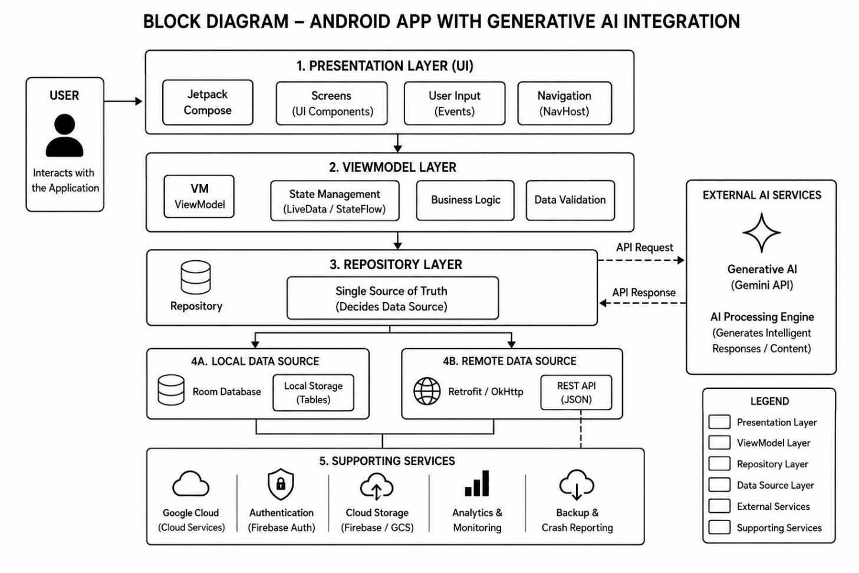
Fig 3.1 System Design Block Diagram

3.4 APPLICATION BUILDING KUTIRA-KUSHALA: INTRODUCTION
Kutira-Kushala is an innovative Android-based mobile application developed to empower home-based cottage industries and self-employed entrepreneurs by providing them with a digital platform to showcase and market their products effectively. In many rural and semi-urban regions, small-scale businesses such as basket weaving, agarbatti making, papad production, handicrafts, homemade foods, and tailoring services remain unnoticed due to lack of digital exposure and direct buyer connectivity.

The application acts as a smart Micro-Factory Showcase platform that enables entrepreneurs to create business profiles, upload product catalogs, display production capacity, and directly connect with bulk buyers through a mobile application. Kutira-Kushala transforms traditional home businesses into digitally accessible enterprises by integrating modern Android technologies with Firebase cloud services and product management systems.

The application promotes self-employment, rural industrialization, and women empowerment by providing business owners with tools to market products, manage customer reach, and update production capacities efficiently. By integrating Firebase Firestore, Cloud Storage, searchable product listings, and interactive product cards, Kutira-Kushala provides a secure, user-friendly, and scalable digital marketplace solution for cottage industries and small businesses.

3.5 KUTIRA-KUSHALA: ABSTRACT
Kutira-Kushala is a smart Android application designed to digitize and simplify cottage industry product showcasing and entrepreneur-business management activities through an interactive digital platform. The application allows home-based entrepreneurs to create professional business profiles, upload product images, display wholesale pricing, and communicate directly with bulk buyers.
The system includes a Product Catalog feature that allows entrepreneurs to showcase products using images, descriptions, and wholesale rates. A Capacity Meter System enables business owners to update production availability such as “Ready to take 200 orders this week,” helping buyers understand manufacturing capability instantly. Additionally, the Direct Connect feature allows buyers to contact entrepreneurs directly for business inquiries and bulk orders.

The application utilizes Firebase Firestore for storing searchable business profiles and product details in real time. Firebase Cloud Storage is used for securely storing product images and manufacturing-area photos. CardView-based product interfaces and category-based filtering improve user experience and make product discovery easier.

By providing organized digital visibility, business networking, and product management facilities, Kutira-Kushala strengthens rural entrepreneurship, improves self-employment opportunities, and enhances the market reach of cottage industries.

3.6 KUTIRA-KUSHALA: OBJECTIVES
• To develop a digital platform for cottage industries and home-based entrepreneurs
• To provide professional business profile creation facilities
• To enable entrepreneurs to upload and showcase products digitally
• To provide wholesale pricing and bulk-order support
• To allow business owners to update production capacity easily
• To improve connectivity between entrepreneurs and buyers
• To provide searchable product categories and business listings
• To store product images securely using Firebase Cloud Storage
• To promote women empowerment and rural entrepreneurship
• To provide an easy-to-use and visually attractive Android application
• To enhance self-employment opportunities using digital technology

3.7 KUTIRA-KUSHALA: PROBLEM STATEMENT
In many rural and small-scale business environments, cottage industries and home-based entrepreneurs face significant challenges in marketing their products and reaching potential buyers effectively. Businesses such as handicrafts, homemade foods, weaving, tailoring, and agarbatti manufacturing often operate without proper digital exposure, making it difficult for them to expand beyond local markets.

Traditional methods of selling products rely heavily on middlemen and local buyers, which reduces profit margins and limits business growth. Additionally, there is no centralized digital platform where entrepreneurs can display products, update production capacity, upload business information, or connect directly with wholesale buyers.

Most small businesses also lack technical knowledge and affordable digital solutions for managing product catalogs and customer interactions efficiently. As a result, many talented entrepreneurs remain economically underdeveloped despite having quality products and production capabilities.
Therefore, there is a need for a digital solution that enables cottage industries and home-based entrepreneurs to create business profiles, upload product catalogs, manage production capacity, and communicate directly with buyers. The proposed system, Kutira-Kushala, addresses these challenges by providing a user-friendly Android application for product showcasing, business management, image storage, and buyer connectivity using Firebase backend services.

3.8 KUTIRA-KUSHALA: ARCHITECTURE
The architecture of Kutira-Kushala is designed using the MVVM (Model-View-ViewModel) architecture pattern to ensure scalability, maintainability, and efficient data handling. The application consists of multiple layers including the Presentation Layer, View Model Layer, Repository Layer, Local Storage Layer, and Firebase Cloud Services.

The Presentation Layer is developed using Jetpack Compose and Material 3 components to create interactive and responsive user interfaces such as Business Profile Screens, Product Catalog Screens, Capacity Meter Panels, and Product Category Filtering Interfaces. The View Model Layer handles business logic, state management, form validation, and communication between UI components and backend services.

The Repository Layer acts as a single source of truth for handling local and remote data operations. Firebase Firestore is used for storing entrepreneur details, product information, capacity meter updates, and searchable category-based product listings. Firebase Cloud Storage is implemented for securely storing product images and manufacturing-area photographs.

The application also integrates searchable product filtering systems and direct buyer communication features for efficient business interaction. CardView-based product displays improve UI presentation and user experience. Navigation Components are used for smooth screen transitions and efficient user interaction.

The overall architecture ensures reliable data management, cloud-based scalability, secure image storage, and efficient business communication between entrepreneurs and buyers.
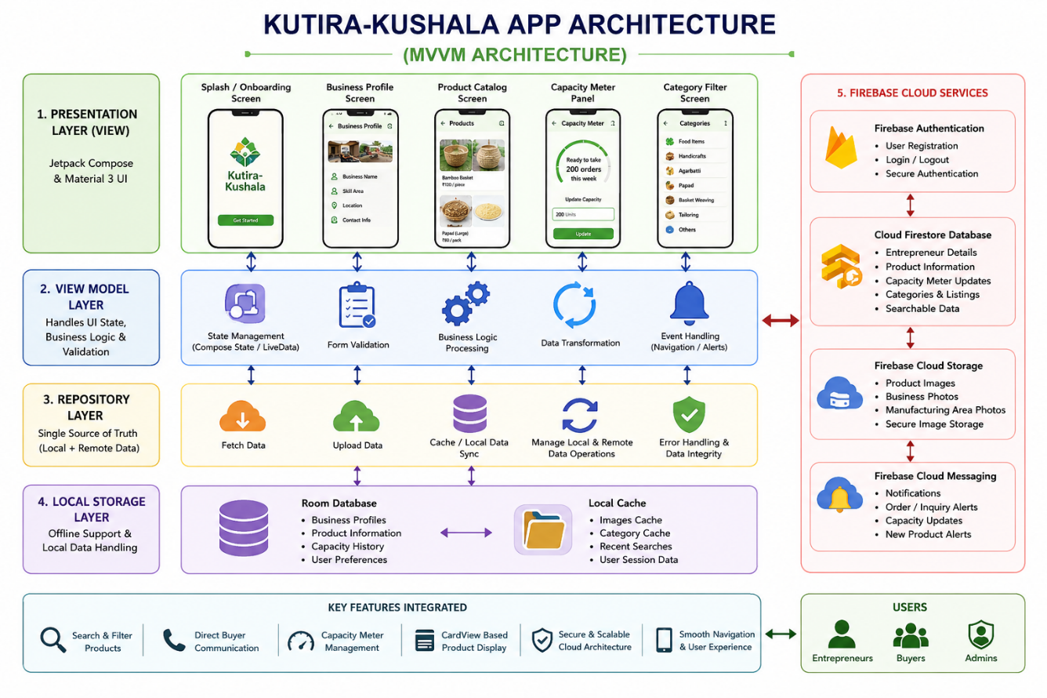
Fig 3.2 Architecture: Kutira-Kushala
3.9 KUTIRA-KUSHALA: TECHNOLOGIES & TOOLS USED
Android Development Technologies
• Android Studio – Android application development environment
• Kotlin – Primary programming language used for development
• Jetpack Compose – Modern UI toolkit for Android applications
• Material 3 – User interface design and theming
Database & Backend Technologies
• Firebase Firestore – Real-time storage of entrepreneur and product data
• Firebase Cloud Storage – Secure storage of product and business images
• Firebase Authentication – User login and authentication support
• Room Database – Local storage and offline support
Additional Technologies & Services
• MVVM Architecture – Structured and maintainable application design
• Navigation Components – Managing screen navigation and transitions
• CardView UI Components – Product showcase design implementation
• Google Cloud Services – Backend support and cloud integration
• Git & GitHub – Version control and project management
UI/UX Features
• Business profile dashboard
• Product catalog with images and pricing
• Category-based product filtering
• Capacity meter update system
• Direct buyer connectivity interface
• Entrepreneur-friendly and visually clean UI
• Firebase-powered cloud storage system

3.10 KUTIRA-KUSHALA: MODULE DESCRIPTION
Kutira-Kushala consists of multiple functional modules designed to simplify entrepreneur-business management and digital product showcasing for cottage industries and self-employed workers.
1. User Authentication Module
This module allows entrepreneurs to securely access the application using Firebase Authentication. Users can create accounts, log in, and manage their business profiles securely. Authentication ensures privacy and prevents unauthorized access to business information.
2. Business Profile Module
The Business Profile Module enables entrepreneurs to create and manage professional profiles containing:
- Business Name
- Entrepreneur Name
- Skill Area
- Business Category
- Contact Information
- Business Location
- Manufacturing Area Photos
This module helps buyers understand the entrepreneur’s background and manufacturing capability.
3. Product Catalog Module
The Product Catalog Module allows users to upload products with:
- Product Name
- Product Image
- Product Description
- Wholesale Price
- Product Category
- Available Stock Information
Products are displayed using CardView-based layouts for better user interaction and product visibility.
4. Capacity Meter Module
This module helps entrepreneurs update their weekly production capacity manually. Business owners can indicate whether they are ready to take bulk orders and specify production quantity availability.
Example:
- Ready for 100 units
- Ready for 200 units
- Currently unavailable
This feature helps buyers understand production readiness instantly.
5. Search & Filter Module
The Search and Filter Module enables buyers to search products based on:
- Product Category
- Business Type
- Location
- Price Range
This improves product discoverability and simplifies buyer navigation.
6. Firebase Cloud Storage Module
This module securely stores:
- Product Images
- Manufacturing Area Photos
- Business Display Photos
Firebase Cloud Storage ensures scalable and secure cloud-based image handling.
7. Buyer Communication Module
This module provides direct connectivity between entrepreneurs and buyers through:
- Phone Call Support
- Contact Details
- Direct Inquiry Facilities
This eliminates middlemen and supports direct business communication.

3.11 KUTIRA-KUSHALA: SYSTEM REQUIREMENTS
Hardware Requirements
For Development
- Processor: Intel i5 or above
- RAM: 8 GB or above
- Storage: 256 GB SSD or above
- Internet Connection
For Mobile Device
- Android Smartphone
- Minimum 3 GB RAM
- GPS and Internet Support

Software Requirements
Development Environment
- Android Studio Hedgehog / Latest Version
- Kotlin Programming Language
- Jetpack Compose
- Firebase SDK
Backend Technologies
- Firebase Firestore
- Firebase Cloud Storage
- Firebase Authentication
Version Control
- Git
- GitHub
Operating System
- Windows 10/11
- Android 8.0 and above

3.12 KUTIRA-KUSHALA: ADVANTAGES
• Promotes rural entrepreneurship
• Provides digital visibility to cottage industries
• Helps entrepreneurs connect directly with buyers
• Reduces dependency on middlemen
• Supports women-led businesses
• Encourages local manufacturing and self-reliance
• Provides secure cloud-based product management
• Enables easy product showcasing with images
• Improves business growth opportunities
• User-friendly and mobile-accessible platform

3.13 KUTIRA-KUSHALA: LIMITATIONS
• Requires internet connectivity for cloud synchronization
• Entrepreneurs need basic smartphone knowledge
• Firebase free-tier limitations may apply for large-scale data storage
• Product delivery and logistics are outside application scope
• Image uploads may require stable network speed

3.14 KUTIRA-KUSHALA: FUTURE ENHANCEMENTS
• Online payment gateway integration
• AI-based product recommendation system
• Multi-language support (Kannada, Hindi, English)
• Order tracking and delivery management
• Buyer review and rating system
• WhatsApp business integration
• Live video product showcasing
• Inventory management system
• AI-powered business analytics dashboard
• QR-code based entrepreneur verification

3.15 KUTIRA-KUSHALA: CONCLUSION
Kutira-Kushala successfully provides a digital platform for cottage industries and home-based entrepreneurs to showcase products, manage business information, and connect directly with buyers. The application transforms traditional self-employment activities into technology-enabled business opportunities through modern Android development technologies and Firebase cloud integration.
The project promotes rural industrialization, women empowerment, and self-reliance by providing entrepreneurs with tools to market products professionally and manage production capacity effectively. Features such as Product Catalog, Capacity Meter, Business Profiles, Search & Filter Systems, and Firebase Cloud Storage enhance usability and improve business visibility.

By integrating Jetpack Compose, Firebase Firestore, Cloud Storage, and modern UI design principles, Kutira-Kushala delivers a scalable, secure, and user-friendly Android application for supporting small-scale industries and encouraging digital entrepreneurship.

CHAPTER 4

RESULTS
4.1 KOTLIN & ANDROID BASICS

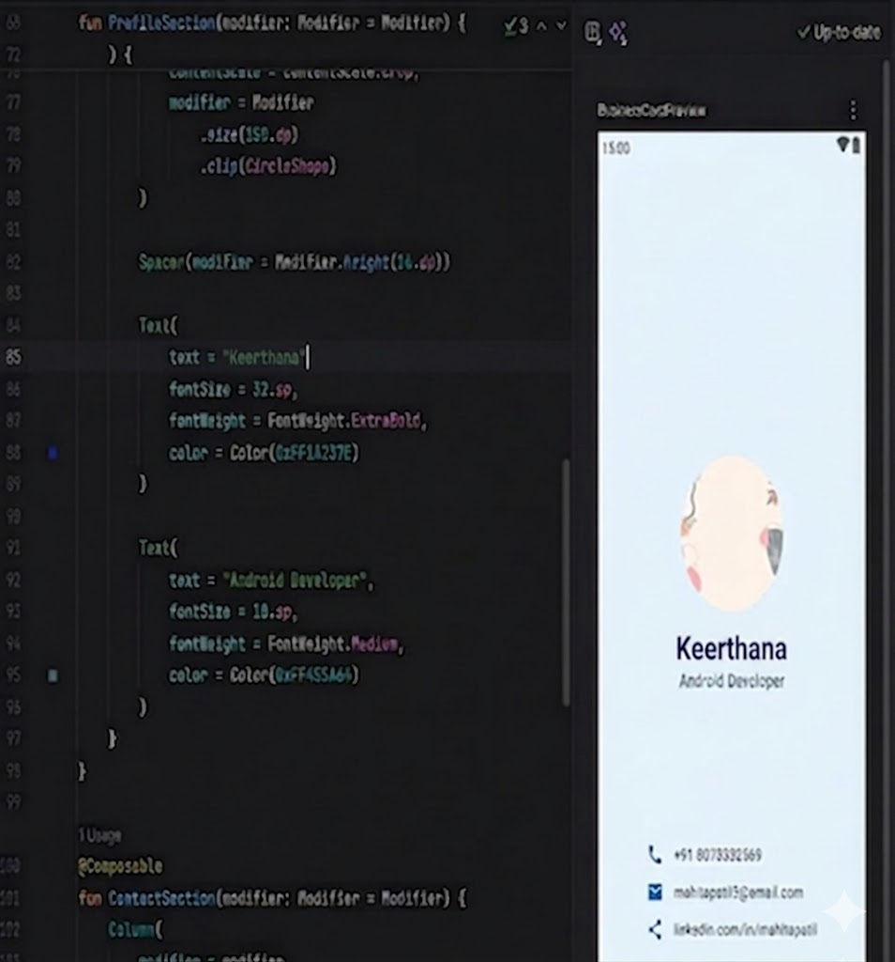

Fig 4.1.1 Business card building



Fig 4.1.2 Business Card

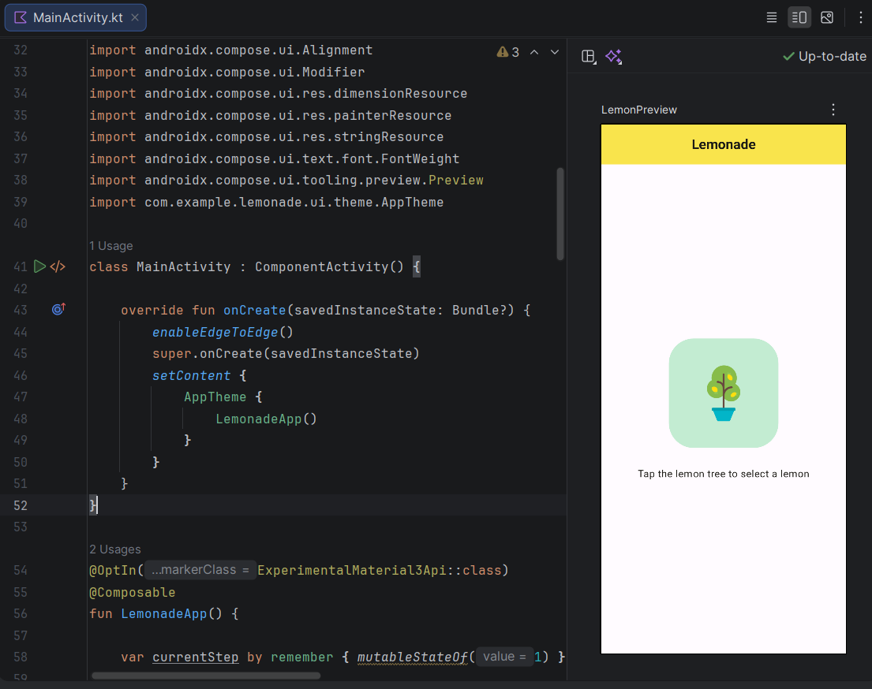
Fig 4.1.3 Jetpack Compose Ui Design

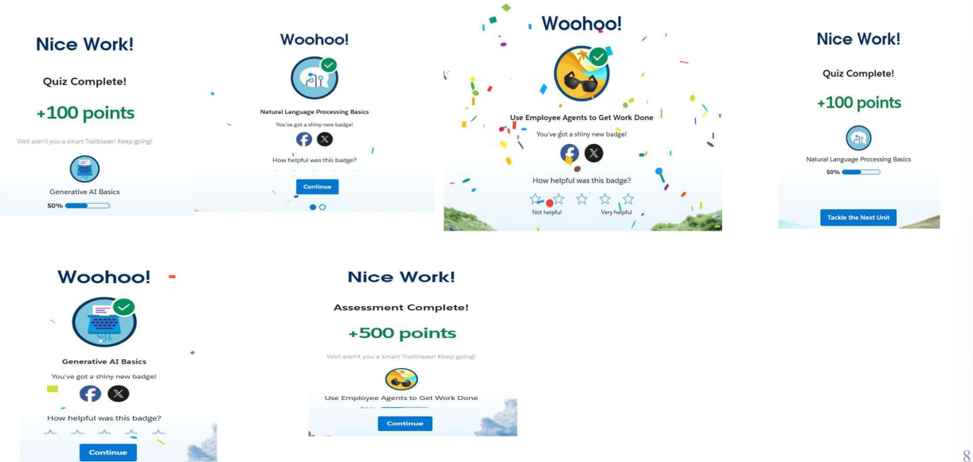

Fig 4.1.4 Google Cloud Badges

4.2 VIDYARTHI-BUS RESULTS

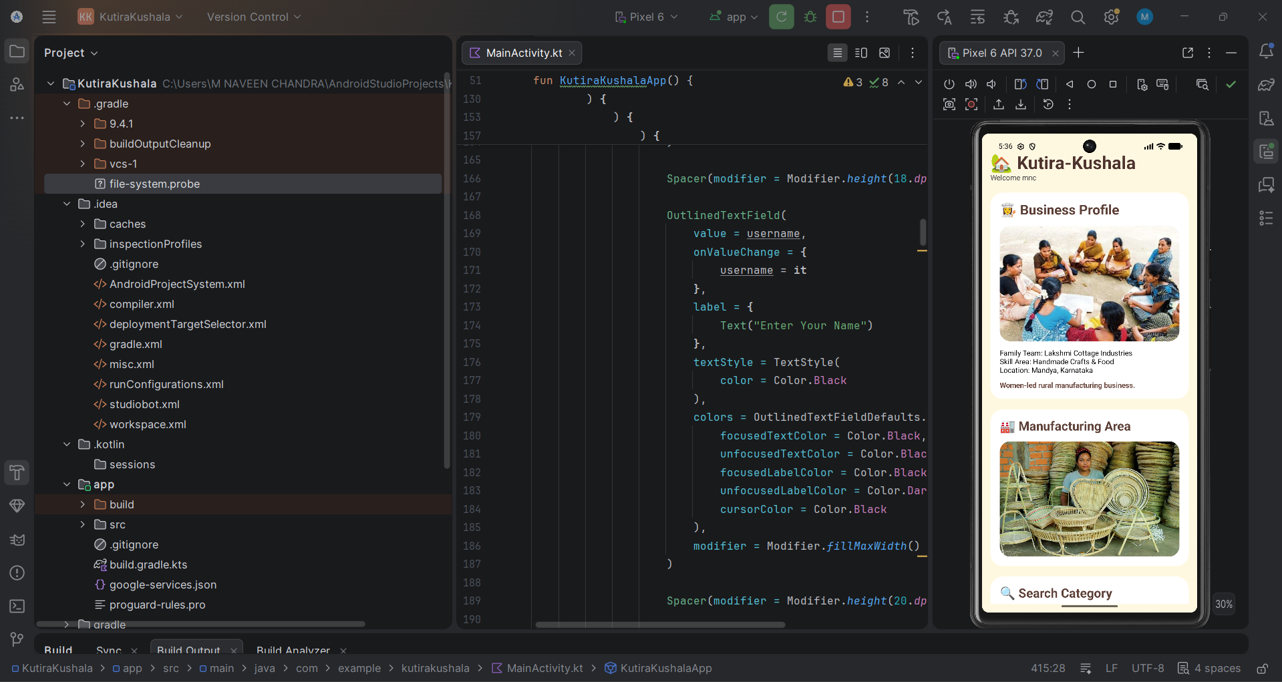

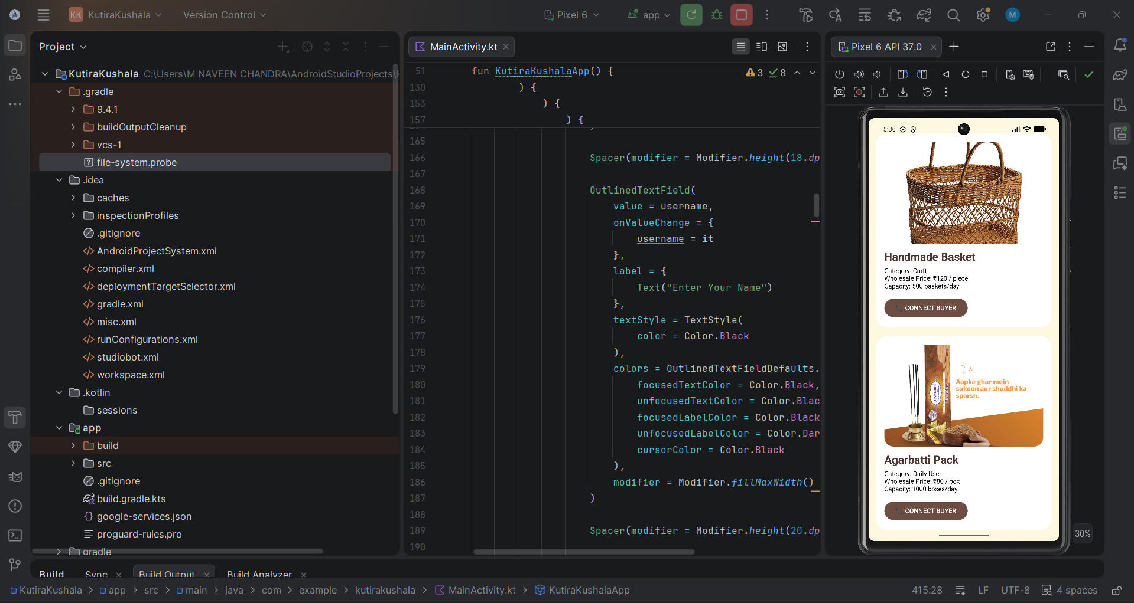

Fig 4.2.1 Android app studio Interface

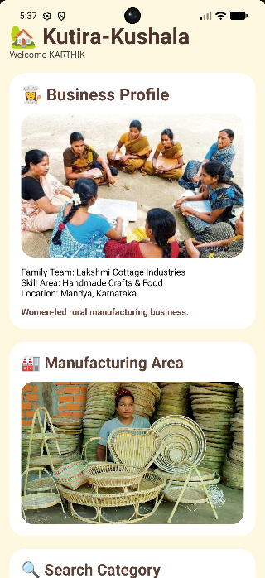

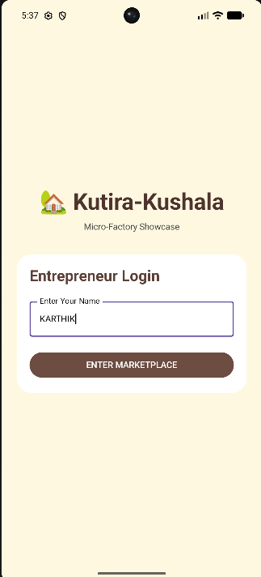
Fig 4.2.2 Kutira-Kushala Business Profile & Marketplace Dashboard
Fig 4.2.3 Overdue Status and Library Catalog


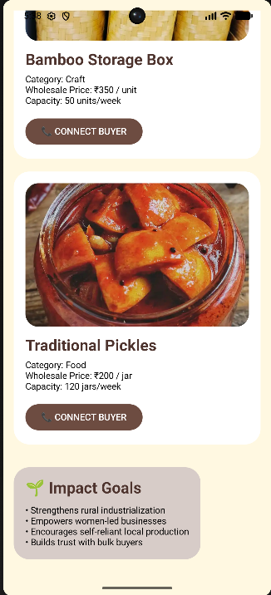

Fig 4.2.3 Product Showcase with Capacity Meter and Buyer Connectivity
Fig 4.2.4 Firebase Realtime Database
Fig 4.2.4 Category-Based Product Filtering and Capacity Meter Interface

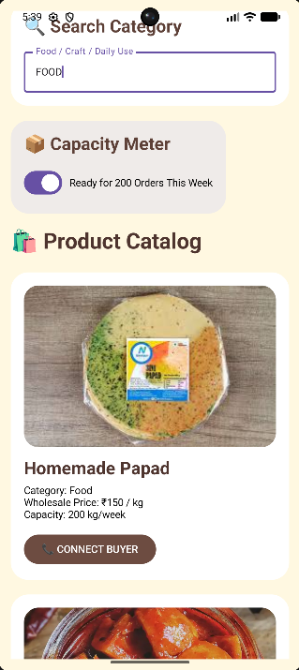

BIBLIOGRAPHY

- Android Developers Documentation
https://developer.android.com

- Google Location Services API Documentation
https://developers.google.com/location-context

- Android Studio Official Website
https://developer.android.com/studio

- Java Programming Documentation
https://docs.oracle.com/javase/8/docs/

- Room Database Documentation
https://developer.android.com/training/data-storage/room

- Camera API Documentation
https://developer.android.com/media/camera

- GeeksforGeeks Android Tutorials
https://www.geeksforgeeks.org/android-tutorial/

- Firebase Documentation
https://firebase.google.com/docs/android/setup

- Android XML Layout Documentation
https://developer.android.com/guide/topics/ui/declaring-layout

- Karnataka Forest Department Resources
https://aranya.gov.in

- Government Guidelines on Sandalwood Harvesting
https://www.karnataka.gov.in/forest

- YouTube Tutorials for Android App Development
https://www.youtube.com/results?search_query=android+app+development+tutorial

